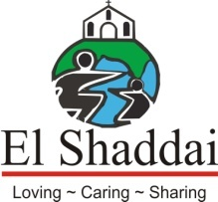

A PROJECT OF EL SHADDAI CHARITABLE TRUST

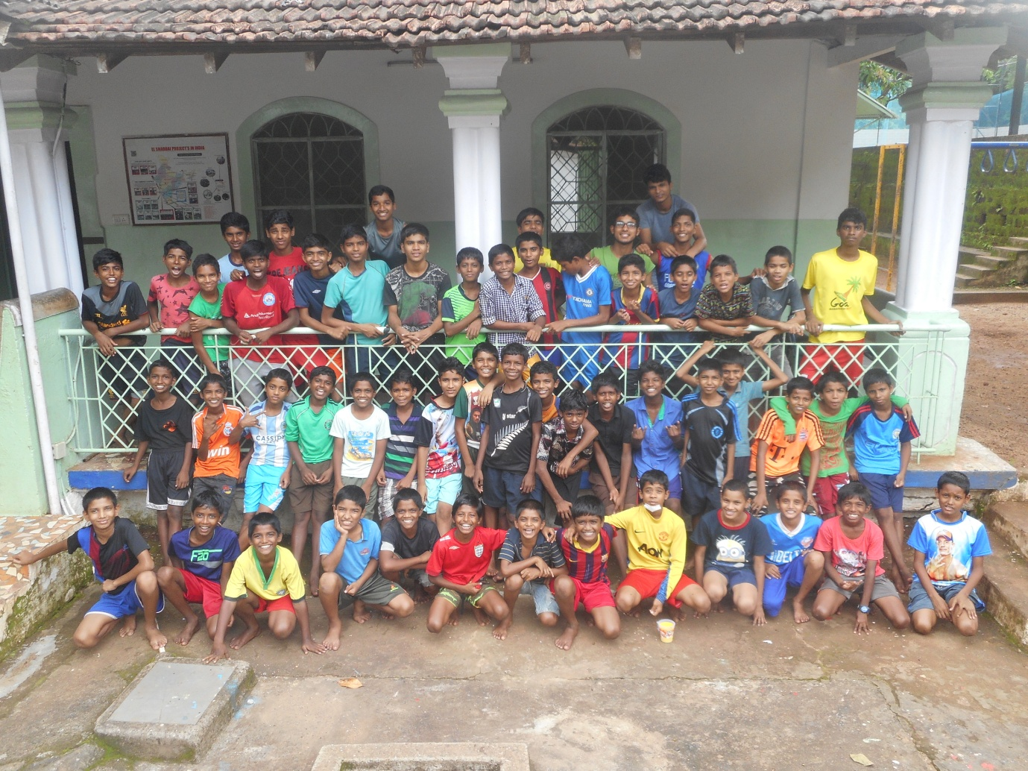
SHEKINAH HOUSE

TABLE OF CONTENTS
Pg. no.

- Introduction 3

- Programmes by El Shaddai 3

- Details of the Project 5

4. Financial Requirements & Costing 5

5. Conclusion 10

Project proposal for running homes for children

About El Shaddai

El Shaddai Charitable Trust is a registered, non-profit charity working in Goa and other states of India, implementing the Child Rights and Juvenile Justice for orphans, street children and children coming from economically underprivileged conditions. In the year 2013, El Shaddai Charitable Trust was accredited by Credibility Alliance which is one of the Leading Accreditation Agencies in India. In August 2017 El Shaddai was awarded by The Goa State NGO’s Leadership, an initiative of World CSR day. El Shaddai was also awarded this year by Amrita TV recognising the effect of Charitable work.

Vision

“Bringing childhood to children who never had one”.

El Shaddai provides such children with:
- Shelter and Care
- Education
- Nutrition
- Health Support
- Awareness Programs

This gives them an opportunity to have a brighter future.

El Shaddai has impacted over 70,000 children and continues to touch more lives through its various initiatives. We want to reach out to many more children with the love and care they deserve.

Programmes by El Shaddai

Homes
El Shaddai is currently running seven homes with 350 children across the state of Goa by providing rehabilitation and compassionate support needed to help children that gives each child in their care a comfortable life leading to self-reliance.

Shelters and Centres
In the North of Goa we have three programmes - Ashadeep, Little Acorns, and Tremara with newly introduced women shelter, House of Hope. In the South, we have three programmes as well- Stepping Stones, Good News, and Ashraya. The slums surrounding these programmes have thousands of children deprived of a normal childhood and thus, these programmes bring comfort and relief to these children. The Shelters and Centres offer protection, education, and teach the children about the significance of health and hygiene.

We have over 2000 children availing the benefits of El Shaddai Day care Shelters, and Centres. Our fieldworkers also work to spread awareness among communities and the children coming off the streets for food and medical attention.

Vocational Training, Classes, and Camps
A large group of around 3000 migrants receive vocational training and are enrolled for Mehendi Designing, Tailoring, Computer Classes, Beautician Courses, and Adult Literacy classes. Counselling, Awareness, Medical, and Health camps are also conducted in the slums.

Meals on Wheels
El Shaddai’s “Meals on Wheels” Manna Khana Food distribution programme provides free packed meals for the poor, disabled, those living on the streets. Over 300 adults and children benefit from this project; they are provided with takeaway packets on week days in four areas of Goa - Margao, Panjim, Calangute, and Mapusa. Our staff empowers and comfort these unfortunate people with kind words and also enlighten them with awareness programs.

Slum Schools
Slum School project is a uniquely designed program which prepares slum children, for formal education by taking the school to them. This project will provide 1000 children who are living on the edge, marginalized and deprived of the basic education, health facilities and with no financial security with education and comprehensive support services. The children often end up doing domestic chores or get into rag-picking and other anti social activities. This project will allow children from these uniquely marginalized communities in Goa, India to stay off the streets and thrive in mainstream school environments.

Women's shelter
House of Hope is a project of El Shaddai Charitable Trust in collaboration with Goa State Urban Development Agency started accommodating urban homeless females in their shelter home, a safe place providing protection and support, catering to the primary needs of women in difficult circumstances like domestic violence, abuse, sexual assault and mental stress and empower them to get back to normal life. The women in need are involved in skill development program like tailoring, , gardening, personality development.
Community Sponsorship
Many children from the underprivileged section have migrated from other states and are left with nothing. Some are drop outs and are not able to continue with the schooling due to financial challenges and the ongoing crisis. Community Sponsorship is an initiative of El Shaddai, through which we provide support and scholarship especially parentless, single parent with no proper infrastructure and also for the children who are good at academics, but are financially challenged to pursue their studies.

PROJECT DETAILS AT A GLANCE:

Project title | Rescue deprived and street children who are in need of basic necessities and shelter.
Project Status | Ongoing
Implementation | Shekinah House
Proposed Project period | 1 year
Project Goal | Provide them Residential homes, good education and the tools of life to enable them to have a better future.
Target beneficiaries | 50 children (Boys)
Areas | Assagao
Annual Financial Assistance | RS. 2345700=00

SHEKINAH HOUSE is our second home, situated at Assagao. It was inaugurated in the year 2000; there are 50 boys between the age of 11 to 18 years staying in Shekinah House enjoying peace and tranquillity of this substantial home. All these children come from the Slums, street, broken family, economically weaker section of the society and some are Orphans.

Food, clothing, medical checkups and education facilities are provided to all the children staying in the home, they attend Shanti Niketan schools run by El Shaddai and some attend formal school. All the boys love participating in extracurricular activities which includes Arts and sports such as Football, Basket ball, Cricket and different indoor games at Shekinah House.

Apart from basic education the children who pass out from secondary school are given opportunity to pursue their carrier by enrolling them for further studies in colleges and complete their Graduation/Post graduation in different streams.

Objectives:
- Individualized care and ensure wholesome development of children
- Children are cared till they are independent
- Make them feel at home by providing them care, love and a sense of belongingness
- Conduct different activities for the personal growth and building self confidence
- Vocational training

Beneficiaries:

- Marginalized/slum/street children and Orphans
- Children Deprived of food, education, shelter
- Children belonging to broken families
- Economically weaker section of the society

Strategy Interventions:
- Align projects as per the objectives
- Provide food, clothing and shelter
- Provide Education to the children
- Make them self independent and build confidence
- Empowering children with vocational training as per their talents

Sustainability

- Regular and sustained awareness and counseling
- Provide a home
- Developing more support staff to take care of the children
- Develop long term linkages with the stakeholders

Major Challenges

- Street Children deprived of a home
- Children do not receive proper education and food.
- Coping up with higher studies is a challenge for poor children
- Developing confidence and achieve the best as per their abilities
- Domestic violence and abusive parents

SHEKINAH HOUSE
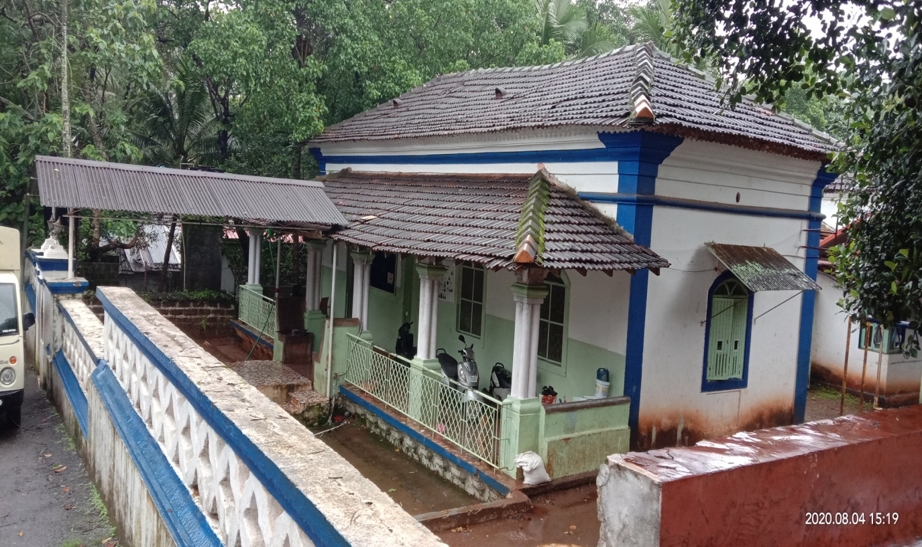

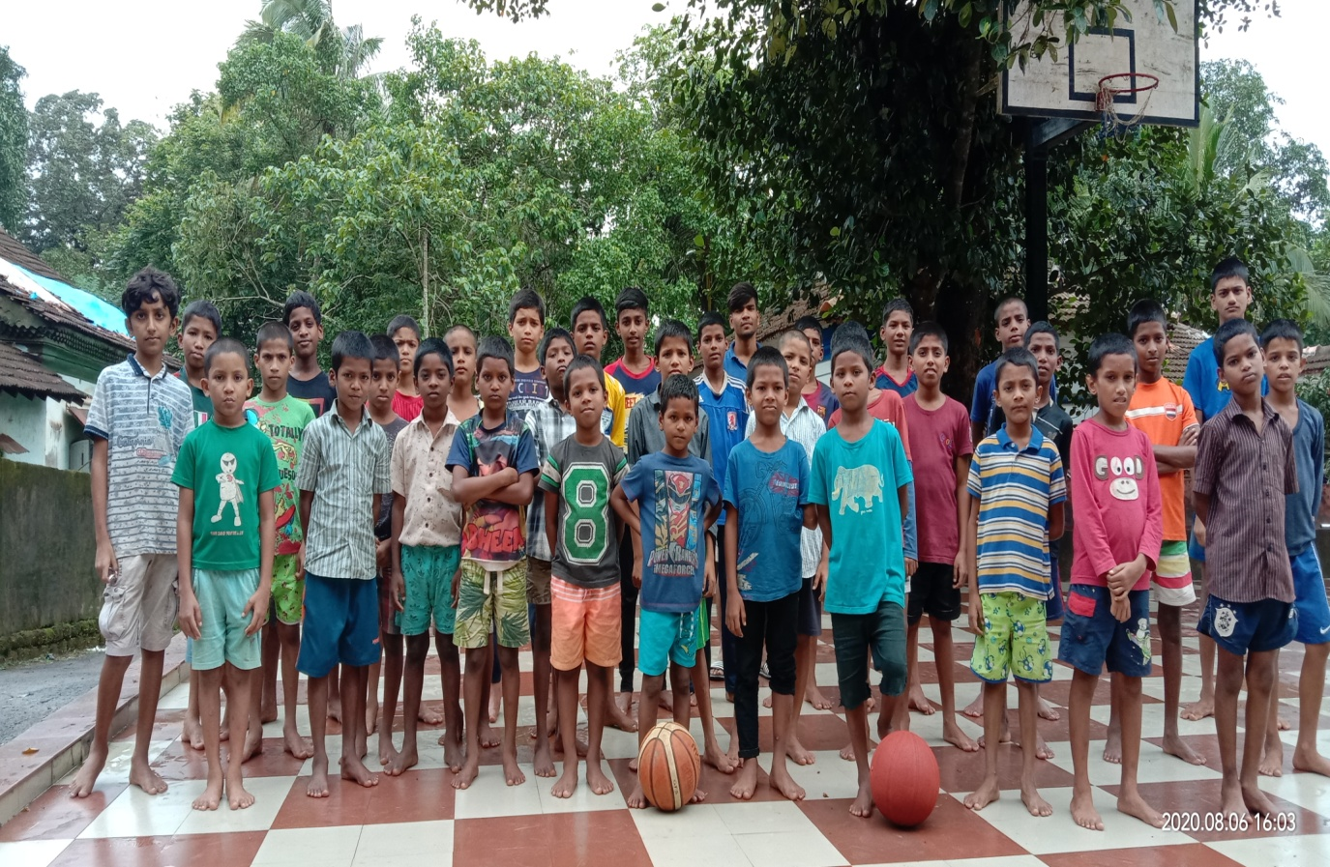

COST REQUIREMENTS FOR THE EXISTING PROJECT:

BUDGET FOR RUNNING A HOME
Food Expense | Monthly cost | Yearly cost | Total in Rupees
Provisions and Food stock | 70000 | 840000
Utilities and Consumables | 3250 | 39000 | 879000
School Expense
Education Expenses includes College fees, Uniforms and study material. |  | 150000
Stationery Items/Postage | 3000 | 36000
Sports Items | 500 | 5000
Learning Aids | 1000 | 12000 | 153000
Staff salary
Home In charge | 20000 | 240000
Assistant In charge | 18000 | 216000
Support Staff -1 | 15000 | 180000
Support Staff - 2 | 15000 | 180000
Helper/Cleaner | 12000 | 144000 | 960000
Travelling /Petrol/Insurance and Utility
Travelling expenses |  | 9000
Petrol and Diesel Expenses |  | 6500
Electricity and water | 3600 | 43200
Repair and Maintenance of Home | 9000 | 108000 | 166700
Other Expenses
Medicines Expense | 2000 | 24000 | 24000
Conducting Programmes/celebration and Gifts  Staff Training |  | 113000 | 113000
GRAND TOTAL RS.2345700 =00
Conclusion

The interaction of our field workers with the slums dwellers and people living on the streets brought to our notice a very urgent need for rescuing street children, and supporting the children who are prone to abuse. So Children’s Home has a significant meaning for El Shaddai, giving a ray of hope for the unprivileged children. We want to ensure our children are given back their rights to enjoy life and not fight for it.

Your support and generosity will be highly appreciated.

