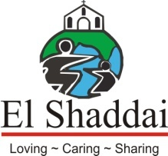

RECURRING COST FOR RUNNING A CHILDREN HOME

SHEKINAH HOUSE,
NORTH GOA

Shekinah House, Val Vaddo
Assagao Goa, 403507

A Project of El Shaddai Charitable Trust

Tel: 08322268206
Email: shekinah@childrescue.net

INTRODUCTION
The El Shaddai Charitable Trust is a registered, non-profit, non-sectarian and non – religious Charity started by Anita Edgar and Matthew Kurian. El Shaddai operates in Goa and other States in India, implementing the Child Rights Act 2003/05 for orphans, street children, and children coming from economically desperate conditions.

Here the underprivileged children and destitute women and men are cared and provided with food, clothing, shelter, and education, for a better future. We have six residential Homes, three Day Care Centres, three Community Centres, Destitute Women and Men shelter, four schools, and Cottages for seniors who are attending University, Colleges, Technical Institutions and Professional Training Centres & working.

We have Meals on Wheels, Manna Khana free food distribution programme on daily basis. Manna takeaway packets are provided for around 700 poor & needy children & adults living on the streets. We have Community sponsorship Programme for the financially challenged children. We have 39 slum schools and slum outreach programme which provide educational facilities and Community health camps for the slum children and women. In addition, our Outreach Projects are touching and changing lives in the South-West States in India.

El Shaddai has impacted over 5000 children in the state of Goa and is currently supporting more than 70000 children/families in India through various outreach projects.

PROJECT – SHEKINAH HOUSE

Sir, Your willingness to support Shekinah House is highly appreciated,

SHEKINAH HOUSE was our second home, situated at Assagao. It was inaugurated in the 2000; there are 60 boys between the age of 9 to 18 years staying in Shekinah House enjoying peace and tranquillity of this substantial home. All these children come from the Slums, street children, broken family, economically weaker section of the society and some are Orphans.

Food, clothing, medical checkups and education facilities are provided to all the children staying in the home, they attend Shanti Niketan schools run by El Shaddai and some attend formal school. All the boys love participating in extracurricular activities which includes Arts and sports such as Football, Basket ball, Cricket and different indoor games at Shekinah House.

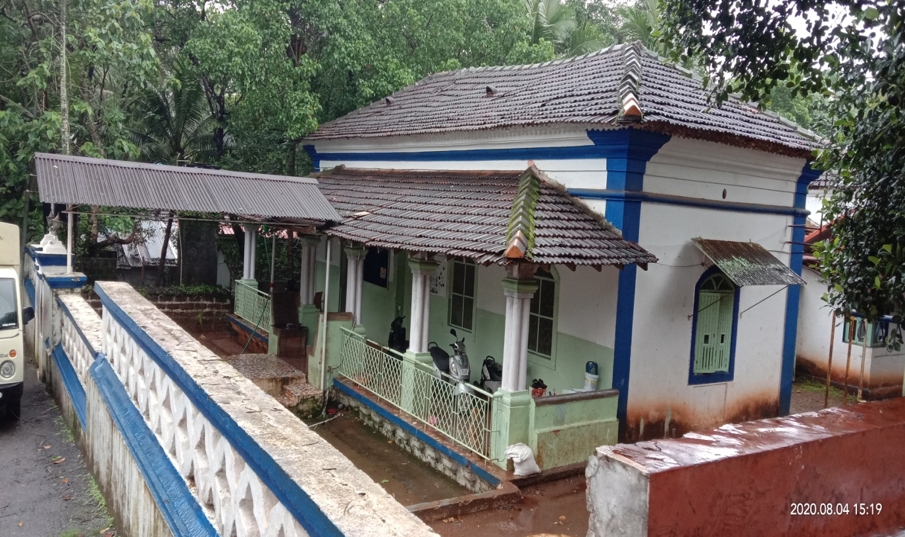

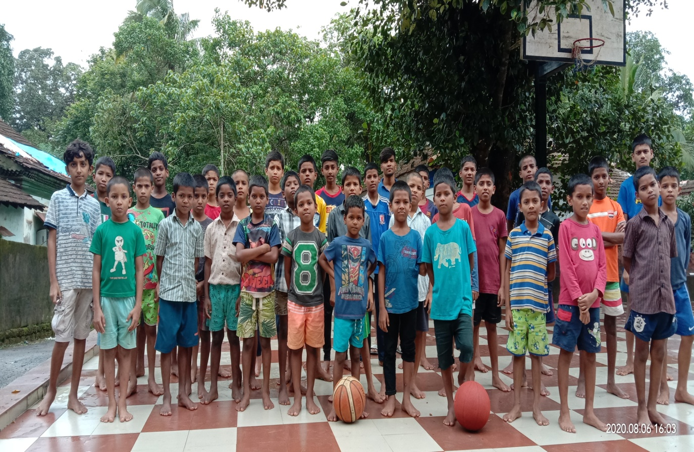

RECURRING COST
Sr. No. | Particulars | Monthly Cost Rs. | Annual Cost
1 | Cost per Child for 60 Children @Rs. 3000  (Includes Food, Clothing, Shelter, education and Routine medical Checkups) | Rs.180000 | Rs.2160000
2 | Electricity | Rs. 2000 | Rs.24000
3 | Travel | Rs. 2000 | Rs. 24,000
4 | Telephone | Rs. 1500 | Rs.18000
5 | Water Bill | Rs. 1000 | Rs.12000
6 | Gas Refill – 3 Cylinders @ Rs.900 | Rs. 3000 | Rs. 36000
7 | Stationery | Rs. 2000 | Rs. 24000
 | Staff Salary
8 | In – Charge | Rs.17000 | Rs.204000
9 | Asst. In charge | Rs.14 000 | Rs.168000
10 | Cleaner | Rs.8000 | Rs.96000
11 | Helper | Rs.4500 | Rs.54000
 | Total | Rs.233950 | Rs.2916000

Conclusion:
In 2007-2008 Matthew Kurian, Co-founder & Managing Trustee received the National Award for Child Welfare to give state recognition to voluntary activities in the field of child welfare and development. The government of India has also instituted Rajiv Gandhi Manav Seva Award to honour for individuals for outstanding contribution towards child development, protection & Welfare, 2007-2008 at the hands of Smt. Sonia Gandhi. El Shaddai Charitable Trust has again made a remarkable landmark in the history of its humanitarian line of work by winning the “Spirit of Humanity Awards 2012” in the Child Nutrition Category from the Ameri Cares India Foundation. El Shaddai Charitable Trust is Platinum Certified by GuideStar India for highest level of Transparency and Accountability.

The interaction of our field workers with the slums dwellers and people living on the streets brought to our notice a very urgent need for rescuing street children, and supporting the children who are prone to abuse. So Children’s Home has a significant meaning for El Shaddai, giving a ray of hope for the unprivileged children. We want to ensure our children are given back their rights to enjoy life and not fight for it.

We want to reach out to many more children with the love of God. We have
been accredited by Credibility Alliance which is one of the Leading Accreditation Agencies in India and Platinum Certified by Guide star India for
the highest level of transparency and accountability.

Your support and generosity is highly appreciated and will definitely give an opportunity of a future to the unprivileged children.

PROJECTS BY EL SHADDAI
HOMES
El Shaddai is currently running six homes with 350 children across the state of Goa; these children come from the Slums, street children, broken families, economically weaker section of the society and some are Orphans. Rehabilitation and compassionate support needed is provided to the children once they are admitted according to the individual need to make them confident. The homes provide children with basic necessities like Food, clothing, Shelter, health support, education and recreational facilities.

SHELTERS AND CENTRES
In the North of Goa we have three projects - Ashadeep, Little Acorns, and Tremara and in South Goa Stepping Stones, Good News, and Ashraya. The slums areas have thousands of children deprived of a normal childhood and thus, these projects bring comfort and relief to these children. The Shelters and Centres offer protection, education, and teach the children about the significance of health and hygiene, around 2000 children benefit from this project. A large group of around 3000 migrants receive vocational training and are enrolled for Mehendi Designing, Tailoring, Computer Classes, Beautician Courses, and Adult Literacy classes. Counselling, Awareness, Medical, and Health camps are also conducted in the slums.

EL SHADDAI SCHOOLS
Our NGO focus is education. Working with children in Goa since 1995, we found that most are not able to cope with regular schools. Unable to keep up, they drop out of the system and have no desire to return. We started the Shanti Niketan School in Assagao for these children in our care. Children here learn at different levels but within one learning centre. Our system of education is child centred, and the teaching approach is activity based. There are three phases of learning: Group study, Individualized system and Classroom system. The main aim behind starting the school was to provide street children with an all-around education in a non-competitive environment. Currently we are running four schools namely: Shanti Niketan and First Steps (Assagao), Tremara pre –primary school (Chimbel) and Blooming Buds (Karnataka)

OUTREACH PROJECTS
MEALS ON WHEELS
El Shaddai’s “Meals On Wheels” Manna Khana food distribution programme provides free packed meals for the poor, disabled, those living on the streets, in the slums & beside the road. Around hundreds of adults & children benefit from this Project; they are provided with takeaway packets on week days in four areas of Goa i.e. Margao, Panjim, Calangute and Mapusa. The Staff empowers and enlightens these unfortunate people with awareness programs and also comforts them with kind words. Food packets are provided for around 700 poor & needy children & adults living on the streets in the major cities of Goa.

In April 2012 Matthew Kurian, also received the Excellence Award for National Social Activity 2012 from the Global Achievers Foundation. El-Shaddai Charitable Trust received the Goa State NGO&#39; Leadership award for the year 2017.

El Shaddai also received the NGO challenge South Asia awards for Organization efficiency category and for protection of orphans and street children besides using digital tools for awareness and campaign for child rights in the year 2013. Certificate of Accreditation from Credibility Alliance is being received for adhering to the Desirable Norms prescribed for Good Governance of Voluntary Organisation for the period 2013 to 2018.

