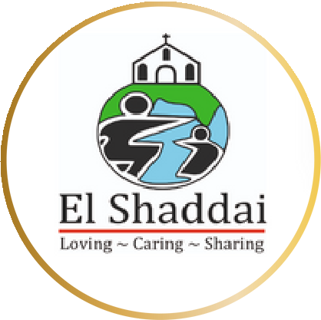

PROPOSAL

CSR
El Shaddai Charitable Trust

Empower Health, Empower life !

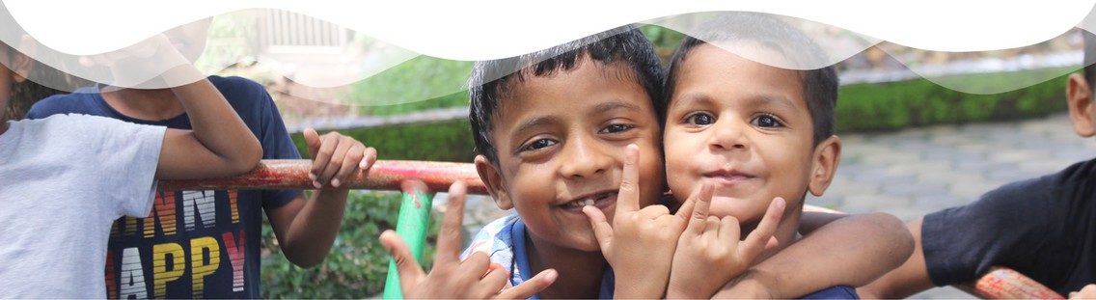
Empowering Lives, Building a Better Future: Partner with El Shaddai Charitable Trust

El Shaddai Charitable Trust, a pillar of hope in Goa since 1997 , transforms the l ives of underprivileged children through education and empowerment programs. Partnering with El Shaddai for your CSR initiative goes beyond strategic investment; i t' s a tangible way to make a lasting difference.

Our mission aligns perfectly with the growing focus on responsible corporate citizenship and sustainable development. By joining forces with El Shaddai, your company gains a meaningful platform to create a positive social impact.

PROUDLY SUPPORTED BY
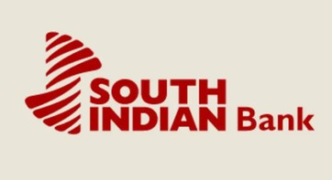
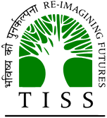
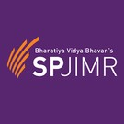
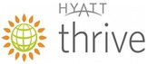
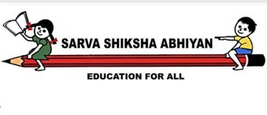

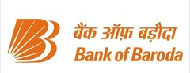

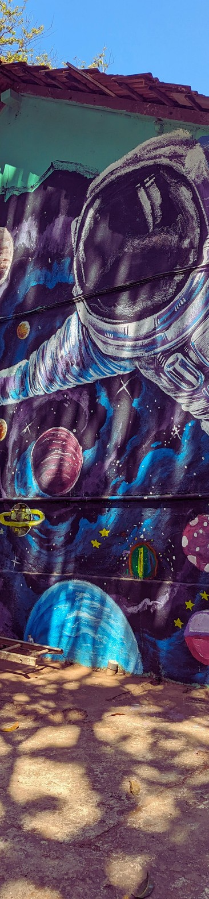

CO- FOUNDERS

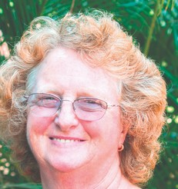
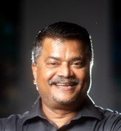
ANITA EDGAR MATTHEW KURIAN

Their paths crossed on one Sunday morning back in 1996 , when the seeds of El Shaddai were sown.

Every child has the divine r ight to enjoy a childhood free of adult worries. A child must think of the next game and not the source of their next meal.

Over 20 years after Anita met Matthew and started the Charitable Trust with Victory House, the first kids they had an impact on are the current Ambassadors of El Shaddai. Leading successful l ives and contributing to society, they give us renewed desire to continue our work with children from underprivileged communities

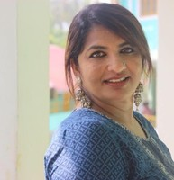
JULIA KURIAN
MANAGING DIRECTOR

A wall art completed by our children along with volunteers in Shantiniketan International School

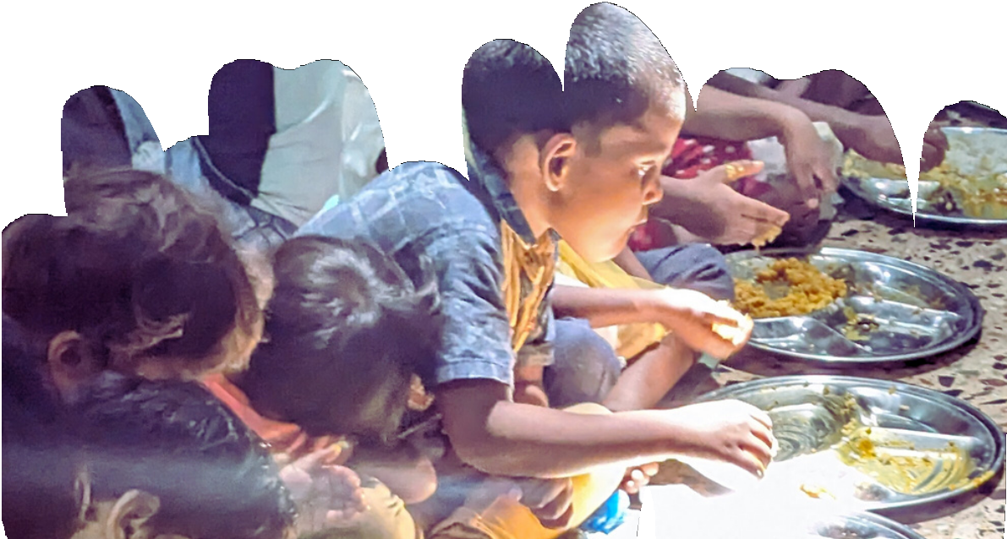
El Shaddai’ s Impact and Alignment with CSR

El Shaddai' s journey, as detailed in our Impact Report 2020 - 2021 , is a testament to the power of compassionate action. Over 70 , 000 children have found hope through our educational and vocational programs. Our residential homes and schools are not just buildings; they are sanctuaries of learning and growth. The daily meal we provide is more than nourishment; it' s a gesture of love and care. By aligning with El Shaddai, your company becomes part of a story of transformation and hope, advancing noble goals l ike quality education and economic growth.

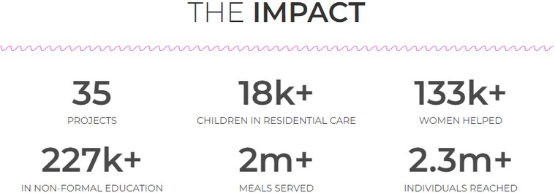
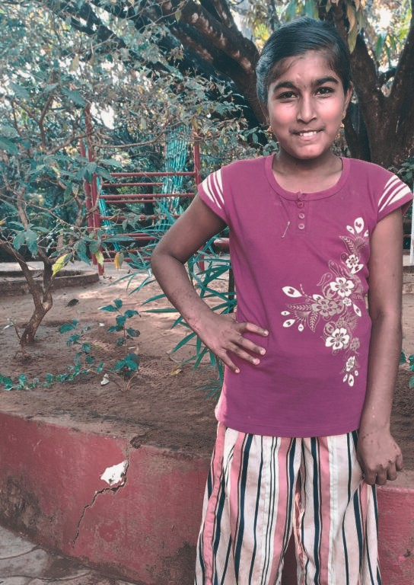
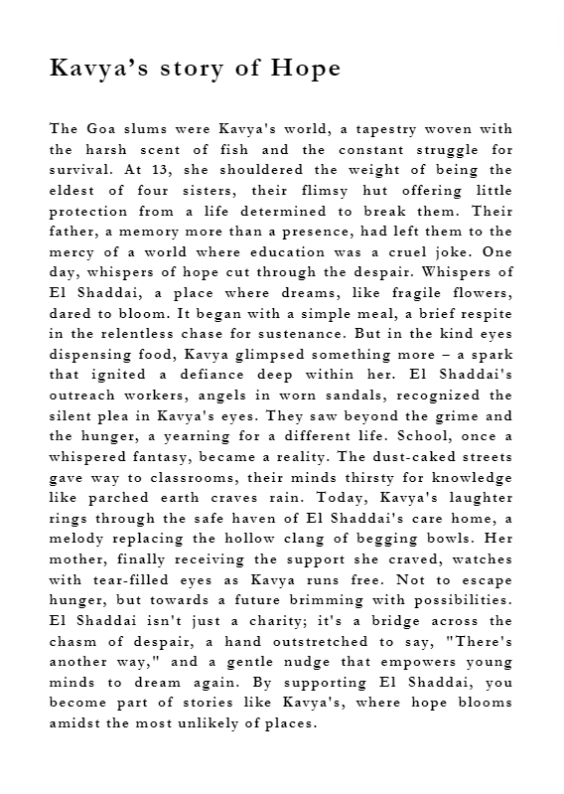
How can you help?
El Shaddai provides a spectrum of partnership opportunities, from sponsoring specific projects to engaging in our overarching mission. Our initiatives are structured to ensure transparency and adherence to CSR norms. We welcome your company to join us in this journey.

Here are our specially curated programs for your organization
The problem of health among the unreached population are limited access to healthcare facilities, lack of awareness and health education, socioeconomic factors, cultural and language barriers, inadequate healthcare resources, gender disparities and prevalence of communicable diseases. Addressing the health problems of the unreached population in India requires comprehensive strategies, including health camps.

Our project aims to make a meaningful impact on the lives of underserved communities by providing essential healthcare services through health camps. Many marginalized and remote areas lack access to proper medical facilities, leaving countless individuals without vital healthcare support. Through our initiative, we will set up health camps, staffed by dedicated healthcare professionals, to deliver much-needed medical care, screenings, vaccinations, and health education.

Solution
Running health camps for deprived populations can significantly contribute to solving the problems through Early Detection and Treatment, Health Awareness and Education, Affordable and Free Services, Addressing Specific Health Needs, Referrals and Follow-ups, Cultural Sensitivity, Capacity Building, Data Collection and Analysis and Advocacy and Policy Influence. By running health camps for deprived populations.

Long-Term Impact
The potential long-term impact of running rural health camps can be transformative and far-reaching, benefiting both the communities served and the broader healthcare system. Here are some of the key long-term impacts: Improved Health Outcomes, Preventive Healthcare Culture, Reduced Healthcare Disparities, Empowerment and Health Education, Strengthened Healthcare Infrastructure, Community Participation, Data Collection and Research, Capacity Building, and Reduced Healthcare Costs.

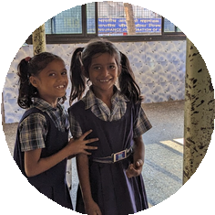
D
El Shaddai, a trusted organization empowering girls and women in need, operates safe havens like Rainbow House and House of Norma. Sanitary pads are a critical, yet often overlooked expense. Your company can make a significant impact by donating pads for the girls in one of our homes – securing their health and hygiene for a month or more.
Here's what your support achieves:
Empowerment: Ensures uninterrupted education and participation in daily activities for our girls. Improved Health: Reduces risk of infections and promotes overall well-being.
Dignity & Confidence: Provides a basic necessity, fostering self-esteem and a positive learning environment.

Please visit childrescue.net to know of our other support programs
Let’ s do this together!

We invite you to join hands with us in this noble endeavour. Reach out to us, and let’ s discuss how together, we can bring about a positive change in the l ives of those in need.

With your support, we can extend our reach, touching more l ives and crafting a future filled with hope and opportunity. Together, let' s build a world where every child has a chance to thrive and every community the strength to f lourish.

Please contact us for more information:
El Shaddai Charitable Trust, El Shaddai House, House No. 265 Socol Vaddo, Assagao, Bardez - Goa, Pin Code:- 403507
Main Contact Mrs. Julia Kurian (Managing Director of El Shaddai) Contact Number 9225901278
Email julia@childrescue.net
Website https://childrescue.net/
To make a direct donation:
FCRA Account:
Account Name:- El Shaddai Charitable Trust. Account No:- 40087469531
Account Type:- Saving Account
Bank Name:- State Bank of India
Bank Address:- FCRA Cell, 4 th Floor, State Bank of India, New Delhi Main, Branch, 11 , Sansad Marg, New Delhi- 110001
IFSC Code:- SBIN0000691

Swift Code:- SBININBB104

