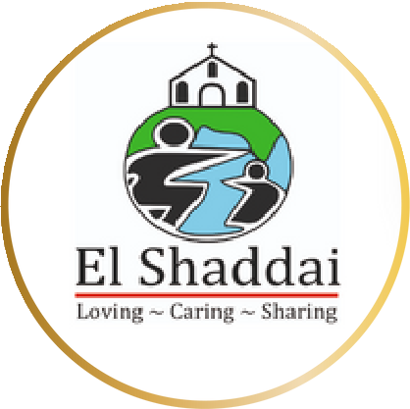

PROPOSAL

CSR
El Shaddai Charitable Trust

Share Hope, Change Lives: Spread Awareness, Save lives!

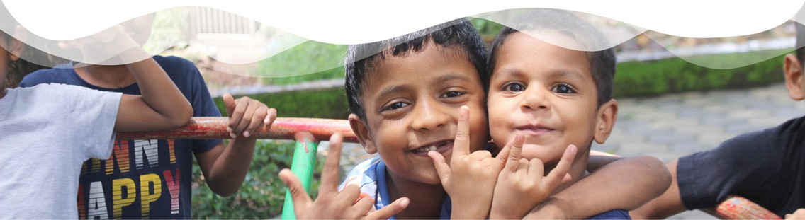
Empowering Lives, Building a Better Future: Partner with El Shaddai Charitable Trust

El Shaddai Charitable Trust, a pillar of hope in Goa since 1997, transforms the lives of underprivileged children through education and empowerment programs. Partnering with El Shaddai for your CSR initiative goes beyond strategic investment; it’s a tangible way to make a lasting difference.

Our mission aligns perfectly with the growing focus on responsible corporate citizenship and sustainable development. By joining forces with El Shaddai, your company gains a meaningful platform to create a positive social impact.

PROUDLY SUPPORTED BY

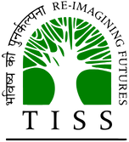
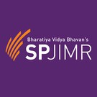
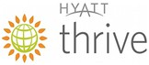
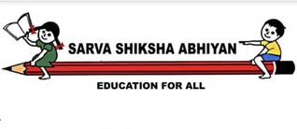

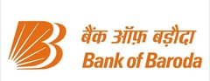

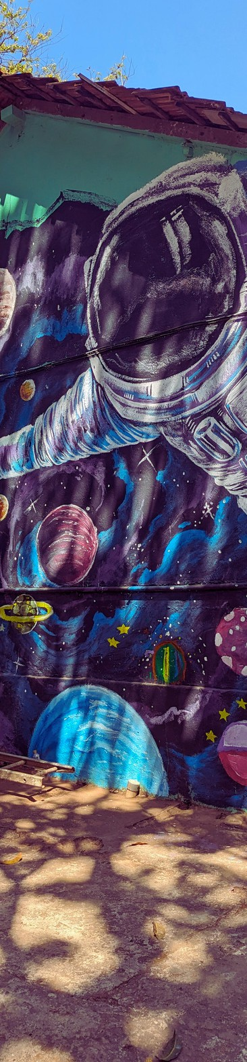

CO- FOUNDERS

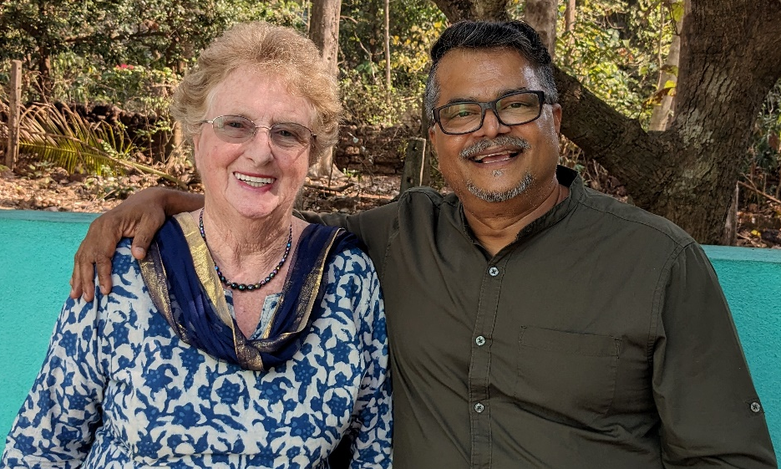

ANITA EDGAR MATTHEW KURIAN

Their paths crossed on one Sunday morning back in 1996, when the seeds of El Shaddai were sown.

Every child has the divine right to enjoy a childhood free of adult worries. A child must think of the next game and not the source of their next meal.

Over 20 years after Anita met Matthew and started the Charitable Trust with Victory House, the first children, they had an impact on the current Ambassadors of El Shaddai. Leading successful lives and contributing to society, they give us renewed desire to continue our work with children from underprivileged communities

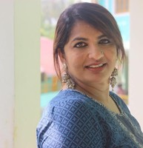
JULIA MATTHEW
MANAGING DIRECTOR

A wall art completed by our children along with volunteers in Shanti Niketan International School

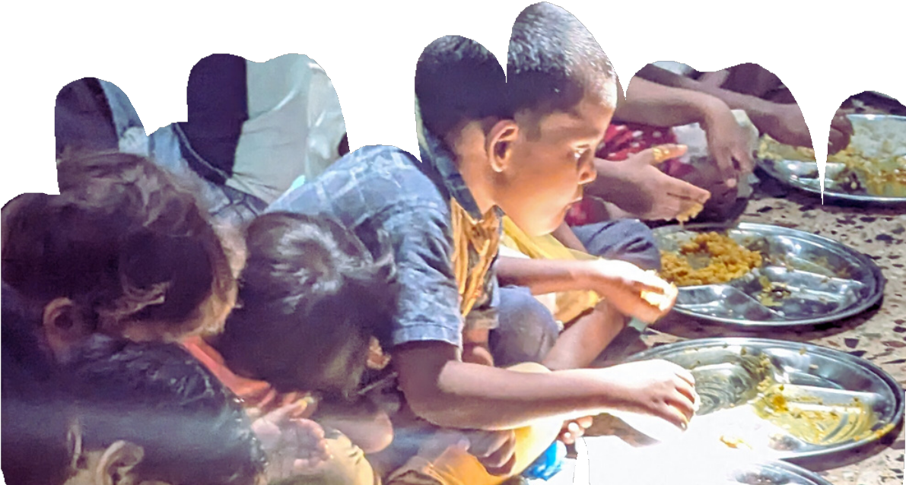
El Shaddai’ s Impact and Alignment with CSR

El Shaddai' s journey, as detailed in our Impact Report 2020 - 2021, is a testament to the power of compassionate action. Over 70,000 children have found hope through our educational and vocational programs. Our residential homes and schools are not just buildings; they are sanctuaries of learning and growth. The daily meal we provide is more than nourishment; it’s a gesture of love and care. By aligning with El Shaddai, your company becomes part of a story of transformation and hope, advancing noble goals like quality education and economic growth.
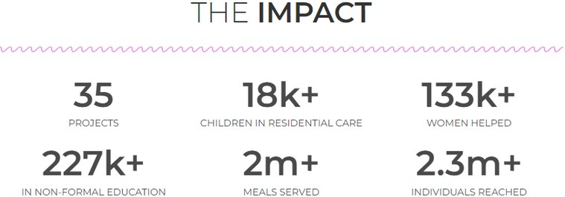
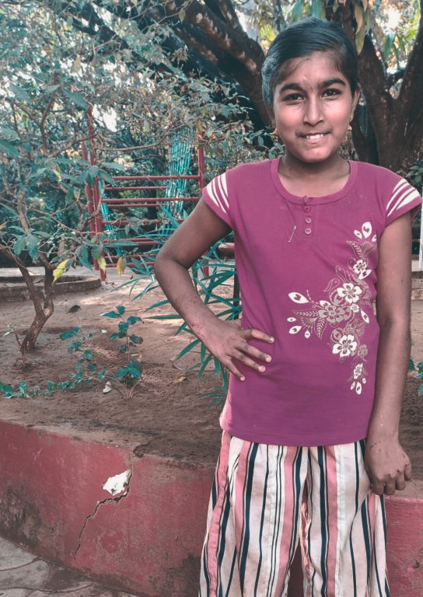
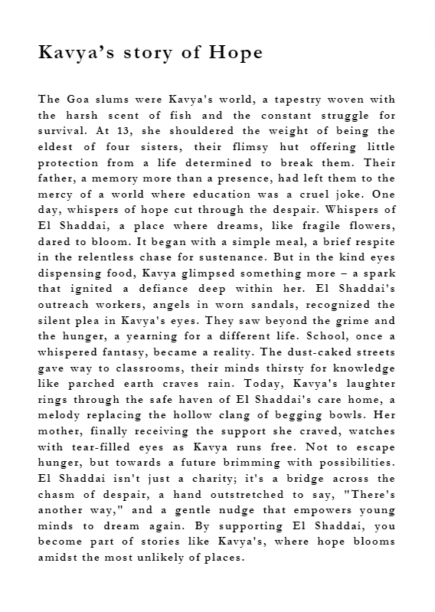
How can you help?
El Shaddai provides a spectrum of partnership opportunities, from sponsoring specific projects to engaging in our overarching mission. Our initiatives are structured to ensure transparency and adherence to CSR norms. We welcome your company to join us in this journey.
Here is our specially curated programs for your organization

Improve healthcare services, Mumbai!

When you choose to help an individual from the street in Mumbai with El Shaddai, you completely transform his/her life in the community.

Since 1999, El Shaddai has been reaching out to thousands of people and children and their communities, providing food and medical attention to the needy, teaching them about fundamental healthcare.

In order to continue and to reach out to more people and children, El Shaddai is in need of a Van with the aim of providing continued community service in Mumbai. Your help will support periodic medical examination helping the people and children to fulfill their hopes. There is an urgent health and nutrition emergency in the city of Mumbai due to the difficult access to free services. In many cases children and people will receive food and medical services faster like:

- Provide affordable health care to people and children.
- Bring health care to the individuals where it is needed.
- Reach the poorest of the individuals in the area.
- Provide care without any discrimination
- Provide basic health education and nutrition.

The preventive healthcare education with healthy nutrition can be now measured with prospects of brighter future.

Your Impact:

Spread the word: Share our mission with your friends, family, and colleagues. By raising awareness, you can help us reach more people and make a greater impact.

Essential resources: Ensures access to necessary materials and supplies.

Holistic Well - being: Contributes to a person’s physical, emotional, and social development.

Please visit childrescue.net to know of our other support programs
Let’ s do this together!
We invite you to join hands with us in this noble endeavour. Reach out to us, and let’ s discuss how together, we can bring about a positive change in the l ives of those in need.

With your support, we can extend our reach, touching more lives and crafting a future filled with hope and opportunity. Together, let' s build a world where every child has a chance to thrive and every community has the strength to f lourish.

Please contact us for more information:
El Shaddai Charitable Trust, El Shaddai House, House No. 265 Socol Vaddo, Assagao, Bardez - Goa, Pin Code:- 403507

Main Contact Mrs. Julia Matthew (Managing Director of El Shaddai) Contact Number 9225901278
Email julia@childrescue.net
Website https://childrescue.net/

To make a direct donation:
FCRA Account:
Account Name:- El Shaddai Charitable Trust. Account No:- 40087469531
Account Type:- Saving Account
Bank Name:- State Bank of India
Bank Address: - FCRA Cell, 4 th Floor, State Bank of India, New Delhi Main, Branch, 11, Sansad Marg, New Delhi- 110001
IFSC Code: - SBIN0000691
Swift Code: - SBININBB104



